Automated Social Media Content Generation Platform

What ? Users get the ability to utilize different LLMs to generate content and post them on different social media platforms automatically and routinly from a single platform.

How? We will be using the different 3rd party API’s that exist. Examples are OpenAI Api and Meta Api combination.

Why? A large majorty of the world already uses social media and another large group of people generate income based on views, likes and engagement. Why not automate this process?

Example :- AI generated text with openAI (a marketing story and a set of similar pictures ) get posted on Instagram everyday for

Challenges
Are AI generates contents that interesting?
Will the tool actually capture what I want to create?
AI hallucinations?

Architectural Design Sktech
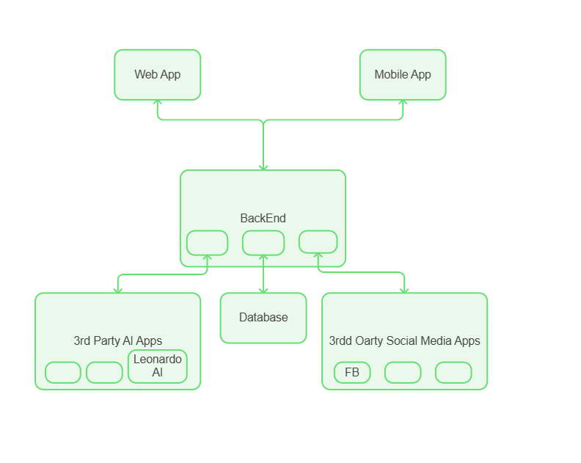
A Simple User Story
We first alow users to connect their differeent accounts, then

By Kaleb Teshale

